IPHCA Disclaimer:

The following document has been developed by subject matter experts based on existing publicly available documents and clinical experience/knowledge. This document, as written, has not been personally vetted by IPHCA. The following policy is meant to provide guidance to FQHC’s in developing their own policies and procedures for employee wellness programs. This is an editable document, and FQHC’s are entitled to edit as necessary for their programs and organizations.

SAMPLE: Employee Well-Being and Resiliency Promotion

Policy and Purpose:
(Insert Organization Name) believes that employee well-being is paramount to organizational success and quality patient care. The following policy serves as the basis of the Health Center’s commitment to establishing and evaluating employee well-being promotion strategies.

Policy Overview
The health and well-being of an employee directly influences their work behavior and on-the-job performance. Burnout is an “emotional and exhausting conditions related to the working environment”¹. In 2018, 78% of physicians reporting feelings of professional burnout at least sometimes². Symptoms of burnout are categorized into three domains: emotional exhaustion, depersonalization, and low personal achievement. While there are a multitude of factors that contribute to burnout, it is most typically associated with work-related stressors including: navigating work/life balance, time constraints on patient care, increased clerical burden, electronic health records (EHR), lack of control, and organizational factors (including misalignment on core values, culture, and leadership behaviors)^{1,3}. A qualitative study conducted by Agarwal et al (2020) identified an overwhelming theme amongst PCP’s related to a clerical workload burden impeded by complex or insufficient organizational workflows that detract from the provider-patient relationship⁴. While research has been predominantly conducted amongst physicians and physicians in training, burnout is experienced across healthcare professionals, and has a contagion effect that further exacerbates the issue.

The Health Center recognizes the serious implications of burnout for organizational wellness, patient quality, safety and satisfaction, and provider health. The Health Center is committed to the development, implementation, and evaluation of comprehensive well-being and resilience promotion to mitigate the implications of burnout.

Evaluating Organizational Contributors of Burnout (modified from McLean and Company research, “Extinguish Organizational Burnout.”)

Overview
“Changing the conversation about burnout requires courage from senior leaders and a willingness to confront difficult conversations. Only when conversations about stress, burnout, and wellbeing are initiated from the top-down will organizations move from a reactive to a proactive environment”⁵.

Employees identify the following six domains as organizational systems that contribute to burnout. Organizational burnout occurs when domains are misaligned resulting in prolonged exposure to stress. The Health Center recognizes the importance of addressing both individual level contributors to burnout, and organizational contributors to burnout, in order to achieve a thriving workplace.

Root Causes of Burnout | Burnout Factor
Workload | - Requests to take on additional work  - Demands to complete work faster
Fairness and Equity | - Unhealthy workplace culture (gossip, ‘isms, office politics, office bullies)
Supervisor and Coworker Relationships | - Lack of supportive managers and coworkers
Role Clarity and Autonomy | - Micromanagement  - Excessively monitored
Recognition and Rewards | - Lack of work recognition
Employee and Organizational Value Alignment | - Poor connection to organizational culture and purpose leads to 11x greater likelihood of burnout

Implementation
- Identify root causes of burnout
  - Identify key roles and responsibilities in evaluating and addressing burnout
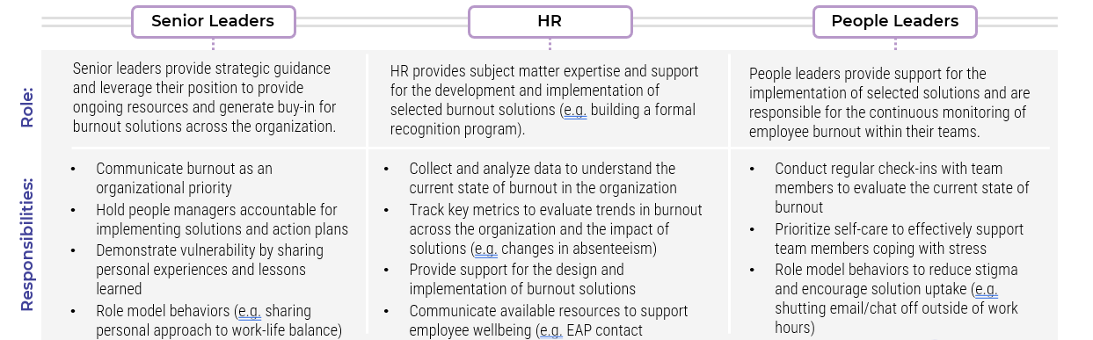

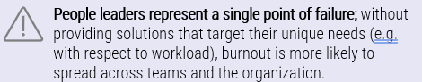

  - Gather existing internal data to assess the current state of burnout

Workforce Data | - Absenteeism (sick days, leaves of absence)  - High performance turnover, voluntary turnover rates
Employee Experience | - Overtime  - Engagement data  - Exit interview feedback
Wellbeing | - Participations rates of current wellbeing initiatives  - Qualitative employee feedback

  - Conduct the Mini Z Burnout Inventory (see section Evaluating Burnout of the Individual Employee)

Evaluating Burnout of the Individual Employee

In order to determine the pervasiveness of burnout across disciplines within the Health Center, the Health Center utilizes the Mini Z burnout survey (appendix A).

Overview
The Mini Z survey is a brief validated tool developed for use in medical providers (physicians and advanced practice providers) and has been adapted for use in nurses, residents, medical students, executive leaders, and teams both inside and outside of healthcare.

The Mini Z is comprised of two subscales, satisfaction and stress, that are related to burnout and would therefore predict employees who may be experiencing burnout.

• Subscale 1: (Satisfaction) → Satisfaction (Q1), Burnout (Q2), Values (Q3) Teamwork (Q4)

The four questions in this subscale focus on positive features of a healthy work
environment including alignment of values with institutional leadership and a sense of teamwork in the workplace. High measures on these two are often linked with high satisfaction and low burnout scores.

• Subscale 2: (Stress) → Stress (Q5), EMR at home (Q6), Documentation time (Q7), Chaos (Q8)

The four questions in this subscale describe the lack of work-place control related to EMR use, pressured time for documentation and a chaotic work environment. Poor scores on these four questions are related to high stress scores and high burnout.

Individual questions (except Question 2) have not been validated as stand-alone measures of either outcomes or drivers of burnout and should not be used independently from the entire survey.

Implementation
The Health Center surveys all employees biannually via an anonymous online survey tool. Outside of department and clinic name, no identifying information is collected. Surveys are evaluated by department and clinic location to best inform global and localized interventions.

Evaluation
Evaluation of departmental stress and satisfaction should be conducted on all 3 domains:

- Overall score: Add all points from the 10 items for a total score, range 10-40 points.
  - A score >=20 is considered representative of a joyful work environment.

- Satisfaction scale: Add all points from Q1, Q2, Q3, Q4, range 4-25 points.
  - A score >=20 is considered a highly supportive environment.

- Stress scale: Add all points from Q5, Q6, Q7, Q8, range 4-25 points.
A score >=20 is considered a low stress environment with reasonable EMR pressures.
Adapted from the Institute for Professional Worklife, the Health Center provides survey feedback to department leaders by job class and clinic location. The Health Center utilizes the following Mini Z templates from the Institute for Professional Worklife:
- Appendix B: Leadership report of survey results
- Appendix C: Employee newsletter report of survey results
- Appendix D: Steering Report

Intervention

(modified from McLean and Company research, “Extinguish Organizational Burnout.”)

- Analyze available data and identify high priority segments
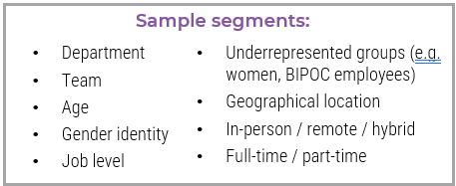

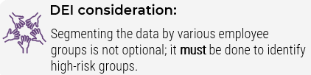

- Conduct focus groups with high priority segments
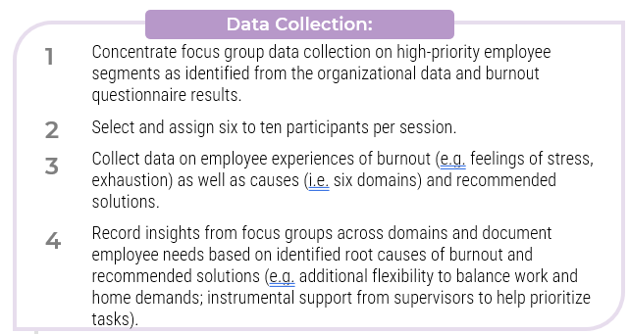

- Identify burnout priority areas: see Appendix E
- Develop solutions to address root causes of burnout: see Appendix E
  - Prioritize solutions based on:
    - Impact: Implementation of the proposed solution will have (minimal, moderate, significant) impact on the current state of burnout and will (slightly, moderately, critically) address root causes of organizational and group level burnout.
    - Effort: investment and time
      - (Minimal, Some, Significant) investment (i.e., time, money, people) is required
      - The solution can be implemented in a (short, moderate, longer) time-period.
  - Identify stakeholders
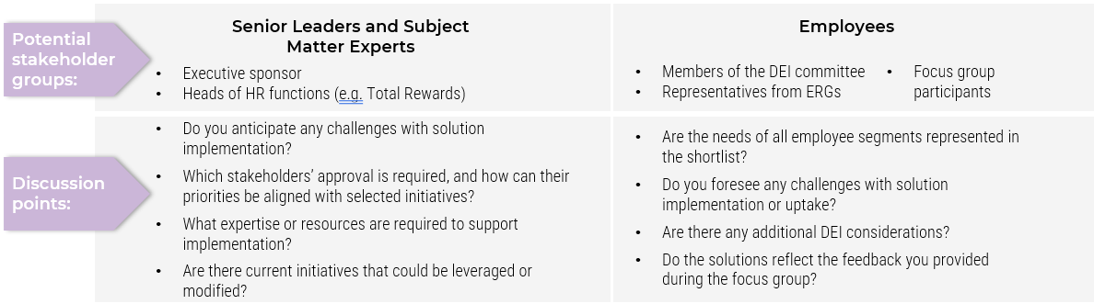

  - Outline the change management process
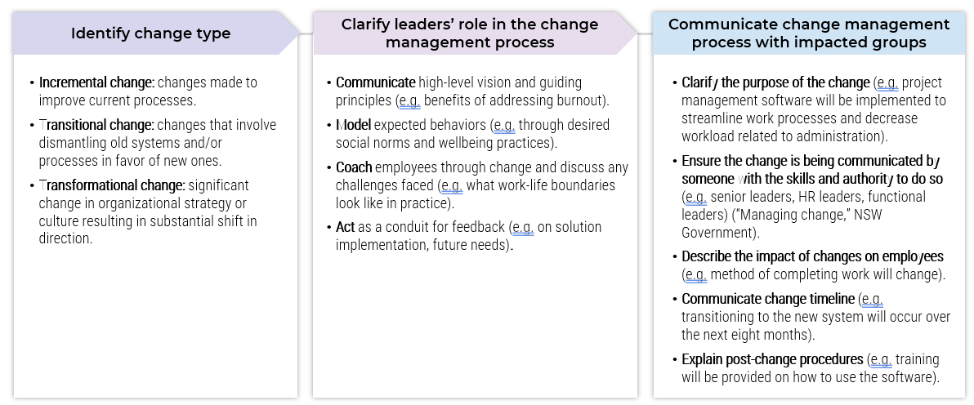

  - Determine accountability structure
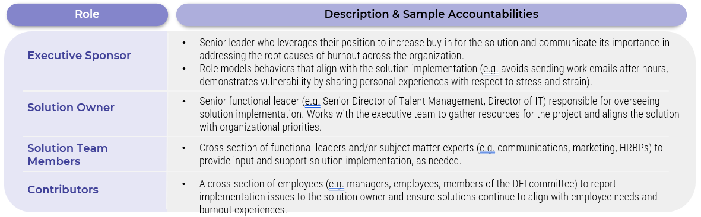

Organizational Programs to Combat Burnout and Promote Wellbeing

The Health Center employees the following strategies to promote wellbeing and mitigate burnout in the workplace:

Employee Wellbeing Committee
The Health Center is committed to ongoing evaluation of employee burnout and intervention to address the root causes. The Employee Wellbeing Committee conducts biannual burnout evaluations allowing the Health Center to proactively identify challenges, intervene, and assess the impact of the strategies implemented.

Support Programming

Group Support
The Health Center provides on-site, peer lead, group support initiatives to provide a safe and confidential space for the processing of workplace challenges and vicarious trauma. Peer support groups are held monthly on the [first/second/third/fourth] [Day of week] on the month during the first hour of regularly scheduled clinic. Participants may join in person or remotely, and schedules are blocked from patient care at this time. Productivity adjustments are made to account for this wellness hour.

Peer Support
The Health Center provides a confidential peer-support connect line. Supported by members of the Wellness Committee, employees may contact a work peer in times of distress and need. The role of the peer support worker is to listen and provide empathy. This is not a crisis intervention or therapeutic encounter. Should a greater need be identified, Peers will navigate workers to additional organizational resources.

Health Center Provided External Resources

Employee Assistance Program
The Health Center employees an EAP service to provide short-term therapeutic services to our employees. EAP services are actively discussed in monthly department meetings, and signage is present in all employee break spaces. Managers are trained on the Health Center’s EAP services as part of their leadership training, and are encouraged to actively utilize the service for themselves and to refer their employees as needed.

Wellness Support Tools
The Health Center provides free access for employees to digital app-based wellness tools. The Health Center recognizes the stigma associated with burnout, and employee concerns related to conveying their personal needs. To mitigate this barrier to seeking support, the digital app program provides anonymity to employees who can then access support 24-7 based on their individual needs.

Dedicated Leadership Development Programming
Enabling current and future leaders with the necessary skillset to feel competent and confident in their role is essential to identifying and mitigating burnout and promoting employee wellbeing. To do so effectively, the Health Center proactively enrolls aspiring and newly promoted leaders for short-term intensive leadership development programming while providing the necessary workload decrease to ensure participation in such programming does not lead to burnout of the participant The intention of such programming includes, but is not limited to, the development of communication skills, development of understanding and insights into team dynamics, and effective intervention strategies.

Team-based Care
To accomplish the primary benefits of team-based care, the Health Center strives to optimize team composition. Truly optimized TBC requires:
  - Evaluation of the patient population to determine the appropriate configuration of the interdisciplinary team
  - Determination of appropriate staffing structures to support that patient population
  - Clearly defined roles and responsibilities that ensure the ability to work to the top of license, while not assigning tasks that exceed these competencies

Appendix A

Mini Z survey 2.0 (for individual scoring)
Score
For questions 1-10, please indicate the best answer. (Numeric score indicated by number next to response.)
1. Overall, I am satisfied with my current job:
5=Agree strongly 4=Agree 3=Neither agree nor disagree 2=Disagree 1=Strongly disagree
2. Using your own definition of “burnout”, please choose one of the numbers below:
5=I enjoy my work. I have no symptoms of burnout.
4=
3=I am beginning to burn out and have one or more symptoms of burnout, e.g. emotional exhaustion.
2=
1=I feel completely burned out. I am at the point where I may need to seek help.
*If you select 1 or 2, please consider seeking assistance – call your insurance provider or employee assistance plan (EAP)
3. My professional values are well aligned with those of my clinical leaders:
5=Agree strongly 4=Agree 3=Neither agree nor disagree 2=Disagree 1=Strongly disagree
4. The degree to which my care team works efficiently together is:
1=Poor 2=Marginal 3=Satisfactory 4 =Good 5 =Optimal
5. My control over my workload is:
1 = Poor 2 = Marginal 3 = Satisfactory 4 = Good 5 = Optimal
6. I feel a great deal of stress because of my job
1=Agree strongly 2=Agree 3=Neither agree nor disagree 4=Disagree 5=Strongly disagree
7. Sufficiency of time for documentation is:
1 = Poor 2 = Marginal 3 = Satisfactory 4 = Good 5 = Optimal
8. The amount of time I spend on the electronic medical record (EMR) at home is:
1=Excessive 2=Moderately high 3=Satisfactory 4=Modest 5=Minimal/none
9. The EMR adds to the frustration of my day:
1=Agree strongly 2=Agree 3=Neither agree nor disagree 4=Disagree 5=Strongly disagree

10. Which number best describes the atmosphere in your primary work area?
Calm Busy, but reasonable Hectic, chaotic
5 4 3 2 1
11. Tell us more about your stresses and what we can do to minimize them:

Total Score
Scoring your Mini Z: add the numbered responses from questions 1-10. Range 10-50 ( >= 40 is a joyful workplace).

Subscale 1 (supportive work environment) = add the numbered responses to questions 1-5. Range 4-25 ( >= 20 is a highly supportive practice!).
Subscale 2 (work pace and EMR stress) = add the numbered responses to questions 6-10. Range 4-25
( >= 20 is an office with reasonable pace and manageable EMR stress!).
Questions drawn mainly from the Physician Worklife Study, MEMO study, and Healthy Workplace study. The Mini Z was developed by Dr. Mark Linzer and team at Hennepin County Medical Center, Minneapolis MN. For more information please view our website: http://www.cpperesearch.org/

Appendix B
Template language for how to present Mini Z survey data to leader(s)

Here is your department’s YEAR Provider Wellness Survey data. You are welcome to schedule an appointment with us if you like to discuss what you see. We would be happy to meet. If no scheduled meeting takes place, here are our suggestions about how to implement change based on the data:
- Look for trends compared to last year
- See if you’re comfortable with your results (low burnout, absence of chaos, good teamwork, reasonable EMR related stress, …)
Here are things that have been found to be helpful with the data in the past:
- If stress or burnout is high, look for the reason(s), check: control over workload, time for documentation, work atmosphere, teamwork, values alignment and EMR at home score
- If values alignment with leaders is low, consider having a specific values discussion with your department (who can help with this – you, a different group, let the reader know)
- If control over workload is poor or marginal, ask your staff what would be a good way to address this (sometimes the answer is easier than you suspect, like giving more schedule flexibility at certain times of the day), or you can use the data to show executive leaders and advocate for changes that would benefit your department
- If documentation time pressure is high, partner with IT (provide a contact name, email or phone number to make it easy to access services). Can dedicate an entire meeting to this topic and invite IT to attend to share tips & tricks
- If work atmosphere (work pace, or chaos) is a challenge, one way to address this is reimagine the work space – try to decrease number of people in the area at one time or limit in/out traffic
- Mental health resources: Employee Assistance Program: 1-800-xxx-xxxx, the National Suicide Helpline: 800-273-8255, and other resources….
- We do report to the (insert name of Executive Leader overseeing wellness program) and we hope it’s ok if we advocate for you with respect to the findings for your department
Please be sure to reach out to us for help if you are concerned about your providers experiencing burnout. We’re always here to help.
Sign your name/group name (e.g. Your Provider Wellness Committee)

References with links to articles:
- A Cluster Randomized Trial of Interventions to Improve Work Conditions and Clinician Burnout in Primary Care: Results from the Healthy Work Place (HWP) Study - evidence based interventions
- Worklife and Wellness in Academic General Internal Medicine: Results from a National Survey - how to portray data; benchmarks for General Internal Medicine and Hospital Medicine
- Joy In Medical Practice: Clinician Satisfaction in the Healthy Work Place Trial- clinician satisfaction
Characteristics of Health Care Organizations Associated With Clinician Trust Results From the Healthy Work Place Study – measuring trust in the organization
- Evaluation of Work Satisfaction, Stress, and Burnout Among US Internal Medicine Physicians and Trainees - Internal Medicine data and gender differences

Appendix C

202X Employee Wellness Survey Results
We are pleased to share the results of the 202X Provider Wellness Survey. Add the parameters for who was invited to take the survey, example: Providers (physicians and advanced practice providers from all hospital departments) employed for more than 6 months at 0.5+ FTE in (MONTH) 202X were invited to participate. The survey was administered in (MONTH), 202X.

On the back are the results of the 10 survey questions, along with the previous three years’ responses (or whatever amount of data you have/want to share).
Response Rate (xxxx/xxxx providers) = XX%
Respondents:
xxxx physicians,
xxx advanced practice providers, xxx self-identified “other” providers
202X Snapshot
xx% satisfied with job (slight increase/decrease from last year)

xx% experience great deal of stress because of job
[watch this because it can turn into burnout if unaddressed]

xx% experience poor/marginal control over workload (a strong burnout predictor)

xx% feel their values align with department leaders [this is a protective factor]

xx% feel their patient care team works efficiently together

xx% experience burnout
See next page (over) for full results

Question (responses reported here) | 2017 | 2018 | 2019 | 2020 | Data Targets* & comments
Overall satisfied with job (agree, strongly agree) | xx% | xx% | xx% | xx% | >80% satisfied
Great deal of stress due to job  (agree, strongly agree) | xx% | xx% | xx% | xx% | <30% stressed  Burnout is a long term reaction to stress, pay attention to stress this year or it could result in higher burnout next year.
Symptoms of burnout (definitely, won’t go away, completely) | xx% | xx% | xx% | xx% | <20% burned out
Control over workload  (poor, marginal) | xx% | xx% | xx% | xx% | <25% poor control
Time for documentation (poor,  marginal) | xx% | xx% | xx% | xx% | <25% time pressured
Work atmosphere description  (very busy, hectic-chaotic) | xx% | xx% | xx% | xx% | <40% chaotic
Professional values alignment with dept. leaders (agree, strongly agree) | xx% | xx% | xx% | xx% | >80% aligned
Degree patient care team works efficiently together  (satisfactory, good, optimal) | xx% | xx% | xx% | xx% | >80% with efficient teamwork
Amount of time spent on EMR at home (moderate, high, excessive) | xx% | xx% | xx% | xx% | <20% moderate high or excessive EMR time at home
Encounter negative experiences due to gender  and/or race (frequently, fairly often) | (not asked) | xx% | x% (gender)  x% (race) | x% (gender)  x% (race) | These correlate with burnout, low teamwork and lack of values  alignment
*National data suggests these may be optimal targets.

Open-Ended Feedback Summary  Summarize top themes from open ended comment. Be sure no individual or departments can be identified.  Don’t need direct quotes, just themes, both positive and negative, that improve understanding of the quantitative data. | Next Steps  Share how/where the data will be shared (in meetings, on an internal website), who will see it (leaders, managers, front line staff), what plans there are for using it (annual plans, incentive plans, CQI plan for dept., etc.).  Add a contact person for obtaining more information (“please feel free to contact…”)

Appendix D

Employee Wellness Annual Comparison Steering Report
 | 2016 (n=24/49, 49% response rate) | 2017 (n= 27/47, 57% response rate) | Targets*
MD | 18 | 18
APP | 6 | 9
Other | 0 | 0
Overall satisfied with job (Agree, Strongly agree) | 57% | 67% | >80% satisfied
Great deal of stress because of my job (Agree, Strongly agree) | 65% | 70% | <30% stressed
Symptoms of burnout (Definitely, Won’t go way, Completely) | 35% | 56% | <20% burned out
Control over workload (Poor, Marginal) | 36% | 59% | <25% poor control
Time for documentation (Poor, Marginal) | 9% | 0% | <25% time pressured
Work atmosphere description (Very busy, Hectic-chaotic) | 64% | 74% | <40% chaotic
Professional values well aligned with department leaders (Agree, Strongly agree) | 68% | 70% | >80% aligned
Degree patient care team works efficiently together (Satisfactory, Good, Optimal) | 55% | 67% | >80% with efficient teamwork
Amount of time spent on EMR at home (Moderate, High, Excessive) | 0% | 0% | <20% excessive EMR at home
Proficiency with EMR use (Satisfactory, Good, Optimal) | 96% | 100% | >90% proficient

*National data suggests these may be optimal targets

Priority Area | Organizational/group level(s) | Goal |  | Metric | Solution
Root cause 1
Root cause 2
Root cause 3
Appendix E

Example:
Priority Area | Organizational/group level(s) | Goal | Metric | Solution
Workload: lack of time to complete tasks | - Finance department  - Women in management roles | Reduce overtime worked among identified groups by 20% over the next two years | - Percentage of overtime worked  - Number of emails sent after hours  - Absenteeism rate  - Turnover rate | - No email outside of work hours policy  - Explore project management software to streamline work processes and minimize workload
Rewards and Recognition: Official recognition programs not in place; employee wins are not celebrated | - Organization-wide | Increase employee engagement rewards and recognition driver scores by 30% over the next 12 months | - Employee engagement rewards and recognition driver scores | - Create a recognition program  - Encourage managers to develop informal recognition programs for their teams
Role Clarity and Autonomy: Role expectations are not clearly communicated to employees | - Entry level roles in HR  - Remote employees | Increase managers’ average People Leadership competency score to “Meets Expectations” over the next 18 months | - Percentage of employees with independent development plans (IDPs) completed  - Employee engagement learning and development driver scores | - Update job descriptions for entry-level roles in the HR department  - Revise manager training to improve onboarding for remote employees

References

- Patel, R. S., Sekhri, S., Bhimanadham, N. N., Imran, S., & Hossain, S. (2019). A review on strategies to manage physician burnout. Cureus, 11(6). https://doi.org/10.7759/cureus.4805
- Physician burnout. (n.d.). Retrieved February 15, 2021, from http://www.ahrq.gov/prevention/clinician/ahrq-works/burnout/index.html
- A crisis in health care: A call to action on physician burnout. (n.d.). Retrieved from https://psnet.ahrq.gov/issue/crisis-health-care-call-action-physician-burnout
- Agarwal, S. D., Pabo, E., Rozenblum, R., & Sherritt, K. M. (2020). Professional dissonance and burnout in primary care: A qualitative study. JAMA Internal Medicine, 180(3), 395–401. https://doi.org/10.1001/jamainternmed.2019.6326
- McLean and Company. (n.d.). Plan to Extinguish Organizational Burnout: Where there’s smoke, there’s fire – use a systems approach to evaluate, address, and minimize employee burnout. Retrieved from https://go.mcleanco.com/organizational-burnout-g?source=google&medium=cpc&creative=617392886055&keyword=organizational%20burnout&matchtype=b&network=s&device=c&campaign=%7bcampaign%7d&utm_source=google&utm_medium=cpc&utm_term=organizational%20burnout&utm_campaign=%7bcampaign%7d&utm_content=%7badgroup%7d&_bt=617392886055&_bk=organizational%20burnout&_bm=b&_bn=s&gclid=EAIaIQobChMIgNap-dL2-QIV8IlaBR3PuQHIEAAYASAAEgIcF_D_BwE

